Vanier College

Computer Science Department

Web Services 420-551-VA

Section 00002

**Project Proposal**

**Nobel Prize API**

Teacher: Sleiman Rabah

Dinal Patel

Craig Justin Balibalos

Jonathan Dimitriu

Table Of Contents:

Proposal Idea ------------------------------------------------------ **3**

GitHub Repo link ------------------------------------------------------ **3**

ERD ------------------------------------------------------ **4**

Resources ------------------------------------------------------ **5**

Filters and Pagination ------------------------------------------------------ **6-8**

URI Relationships ------------------------------------------------------ **9**

Status ------------------------------------------------------ **10**

Proposal Idea:

Our RESTful web service will show information about Nobel prizes. It will show information about people, categories, awards, and publications.

GitHub Repository:

<https://github.com/D3153/nobel-prize-api>

ERD:

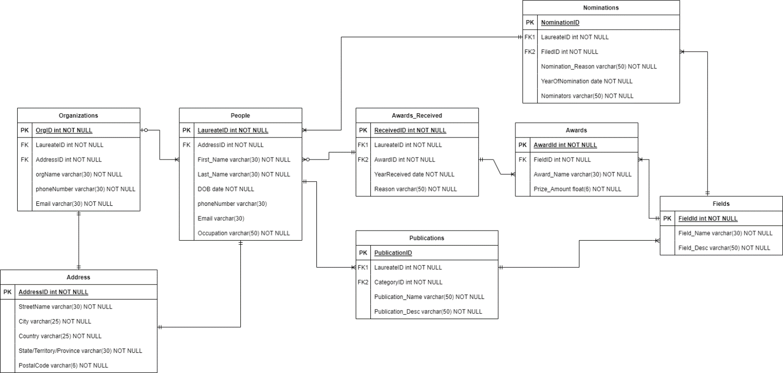

Organizations to People: An Organization can have many People. A Person can either belong to an Organization or not.

Organizations to Address: An Organization has one mandatory Address. An Address belongs to only 1 Organization.

People to Address: A Person has one mandatory Address. An Address belongs to only 1 Person.

People to Nominations: A Person has one mandatory Nomination. A Nomination can belong to many People.

People to Awards Received: A Person can receive 0 or many Awards. An Awards can belong to 1 or many People.

People to Publications: A Person can have 1 or many Publications. A Publication can belong to only 1 Person.

Publications to Fields: A Publication can belong to only 1 Field. A Field can have many Publications.

Fields to Awards: A Field can have only 1 Award. An Award can belong to only 1 Field.

Fields to Nominations: A Field can have many Nominations. A Nomination can belong to only 1 Field.

Resources:

|  |  |  |  |
| --- | --- | --- | --- |
| Name | URI | HTTP Methods | Description |
| Organizations | /organizations | GET, POST, PATCH, DELETE | An *Organizations* resource contains information about an organization. |
| People | /people | GET, POST, PATCH, DELETE | A *People* resource contains information about an person. |
| Awards_Received | /awards_received | GET, POST, PATCH, DELETE | An *Awards_Received* resource contains information about the award_received. |
| Awards | /awards | GET, POST, PATCH, DELETE | An *Awards* resource contains information about an award. |
| Publications | /publications | GET, POST, PATCH, DELETE | A *Publications* resource contains information about a publication. |
| Nominations | /nominations | GET, POST, PATCH, DELETE | A N*ominations* resource contains information about a nomination. |
| Fields | /fields | GET, POST, PATCH, DELETE | A *Fields* resource contains information about a field. |

Filters:

Organization Filters:

|  |  |  |
| --- | --- | --- |
| Name | Type | Result/Expected value |
| name | string | Organizations with the given name are included on the response |
| phoneNumber | string | Organizations with the given phoneNumber are included on the response |
| email | string | Organizations with the given email are included on the response |
| address | string | Organizations with the given address are included on the response |

Pagination:

/organizations?page={page_num}&pageSize={max_size}

People Filter:

|  |  |  |
| --- | --- | --- |
| Name | Type | Result/Expected value |
| firstName | string | People with the given firstName are included on the response |
| lastName | string | People with the given lastName are included on the response |
| bornBefore | date | People who are born before, or on, the date given are included on the response |
| bornAfter | date | People who are born after, or on, the date given are included on the response |
| phone | string | People with the given phone are included on the response |
| email | string | People with the given email are included on the response |
| occupation | string | People with the given occupation are included on the response |

Pagination:

/people?page={page_num}&pageSize={max_size}

Awards Filters:

|  |  |  |
| --- | --- | --- |
| Name | Type | Result/Expected value |
| awardName | string | Awards with the given award_name are included on the response |
| minimumPrizeAmount | float | Awards that has more than, or equal, to the given prize_amount are included on the response |
| maximumPrizeAmount | float | Awards that has less than, or equal, to the given prize_amount are included on the response |

Pagination:

/awards?page={page_num}&pageSize={max_size}

Nominations Filters:

|  |  |  |
| --- | --- | --- |
| Name | Type | Result/Expected value |
| reason | string | Nominations with the given reason are included on the response |
| yearBefore | int | Nominations before, or on, the given year are included on the response |
| yearAfter | int | Nominations after, or on, the given year are included on the response |
| nominator | string | Nominations with the given nominators are included on the response |

Pagination:

/nominations?page={page_num}&pageSize={max_size}

Fields Filters:

|  |  |  |
| --- | --- | --- |
| Name | Type | Result/Expected value |
| fieldName | string | Fields with the given fieldName are included on the response |

Pagination:

/fields?page={page_num}&pageSize={max_size}

Publications Filters:

|  |  |  |
| --- | --- | --- |
| Name | Type | Result/Expected value |
| publicationName | string | Publications with the given publicationName are included on the response |
| description | string | Publications with the given description are included on the response |

Pagination:

/publications?page={page_num}&pageSize={max_size}

URI Relationships:

|  |  |
| --- | --- |
| **URI** | **Description** |
| organizations/{Org_ID}/people | A list of People for an Organization |
| organizations/{Org_ID}/address | An address for an Organization |
| people/{Laureate_ID}/address | An address for a person |
| people/{Laureate_ID}/publications | A list of Publications for a Person |
| people/{Laureate_ID}/awards | A list of Awards for a Person |
| awards/{Award_ID}/people | A list of People for an Award |
| fields/{Field_ID}/awards | A list of Awards for a Field |
| fields/{Field_ID}/publications | A list of Publications for a Field |
| fields/{Field_ID}/nominations | A list of Nominations for a Field |

Status:

|  |  |  |  |
| --- | --- | --- | --- |
| Status Code | Status | HTTP Methods | Description |
| 200 | OK | GET | Request to get resource successful |
| 201 | Created | POST, PUT | Request to create/add new resource successful |
| 202 | Accepted | PATCH, DELETE | Request to modify/delete resource successful |
| 204 | No content | GET | Request to get resource unsuccessful due to not having any resource |
| 403 | Forbidden | POST, PUT, PATCH, DELETE | Request was unsuccessful due to not having authorization |
| 404 | Resource not found | GET | URI does not exist |